MEMBERSHIP FORM

NATIONAL ASSOCIATIONS OF LOCAL GOVERNMENTS

NAME OF THE NATIONAL ASSOCIATION:
Postal address:
City-Postcode:
Country:

Name of the President:
Name and function of designated contact person:
Correspondence to be sent to (e-mails):
Telephone (with country code):

Number of people represented by the Association:
Date of the last census:
Desired date for membership to begin:
Website and social networks:

Applies to join the World Organisation of United Cities and Local Governments and approves its Constitution and Objectives.
Done in (city):
On (date):

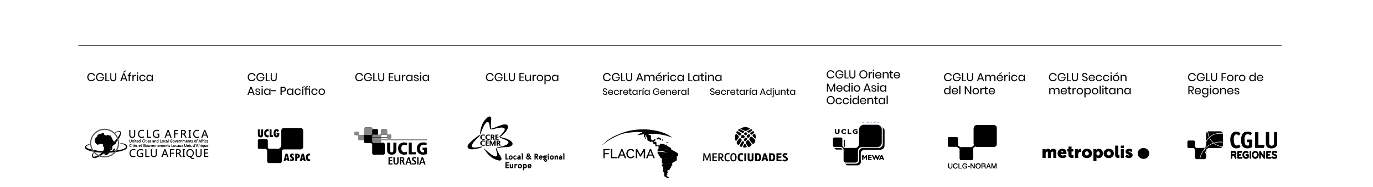

Official stamp and signature

Steps to be taken:
- A formal decision to become a member of United Cities and Local Governments must be taken by the authority with the legal capacity to act on behalf of the Association.
- Submit this form along with a letter of interest to the World Secretariat of United Cities and Local Governments at the following e-mail address: members@uclg.org.

UCLG/CGLU · Carrer Avinyó, 15 – 08002 Barcelona – Spain · Tel: +34 933 428 750 · www.uclg.org

